**Installation of Jenkins on AWS EC-2 Linux**

**#Open AWS Console**

**#Open EC-2 AWS service**

**#Click on Launch Instance with below details.**

1. **Name of machine**
2. **Select OS as Amazon Linux**
3. **In Asia Pacific (Mumbai) zone**
4. **Select instance type as t2. micro free tier**
5. **Create key pair to access server over the putty application.**
6. **Launch AWS EC2 instance.**
7. **Click on security group and add inbound rule for port 8080-jernkins. And same rule**
8. **Now login AWS sever over the putty application using key pair.**

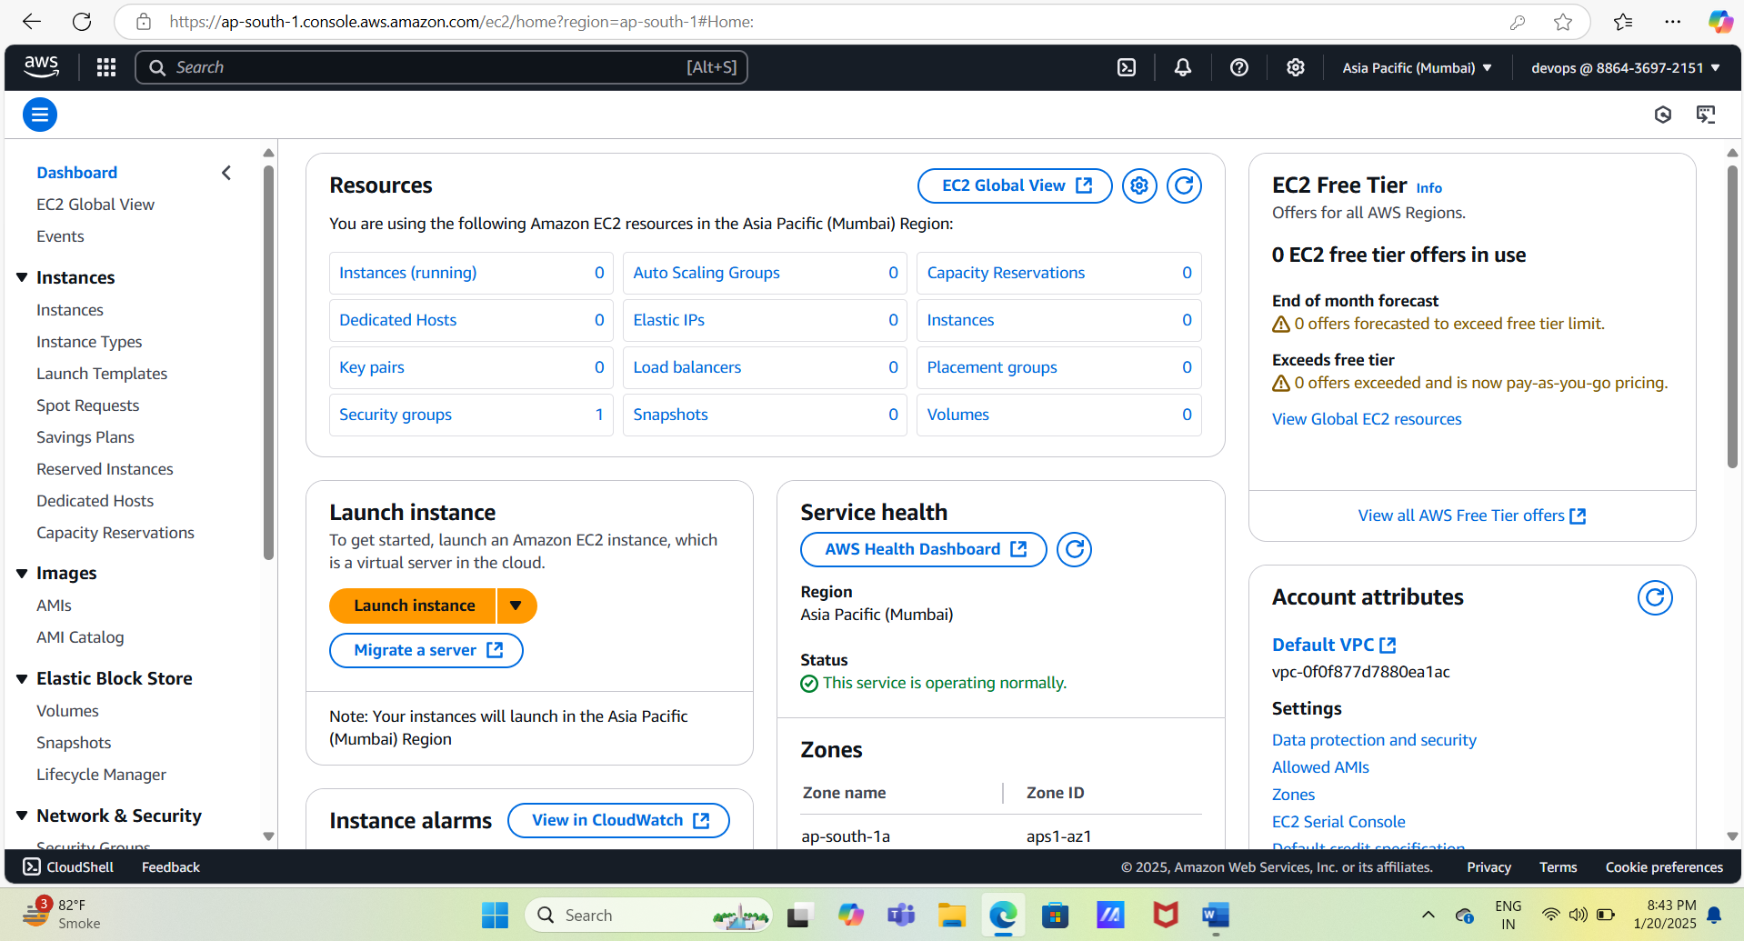

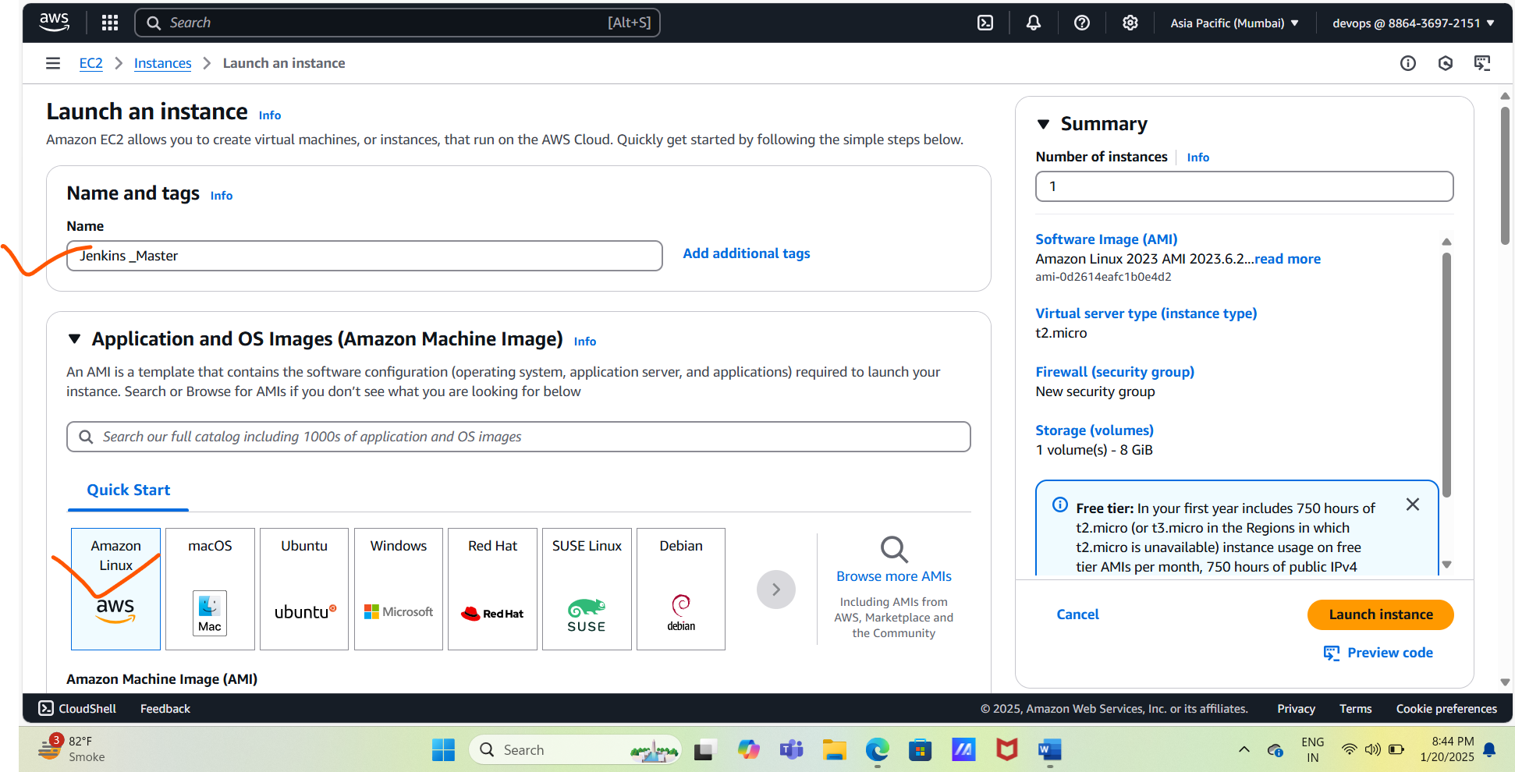

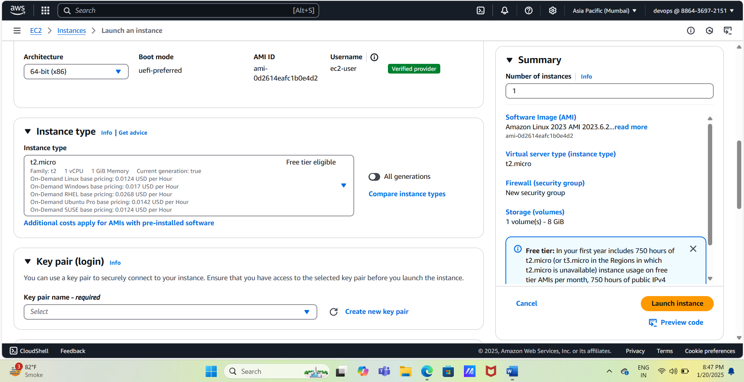

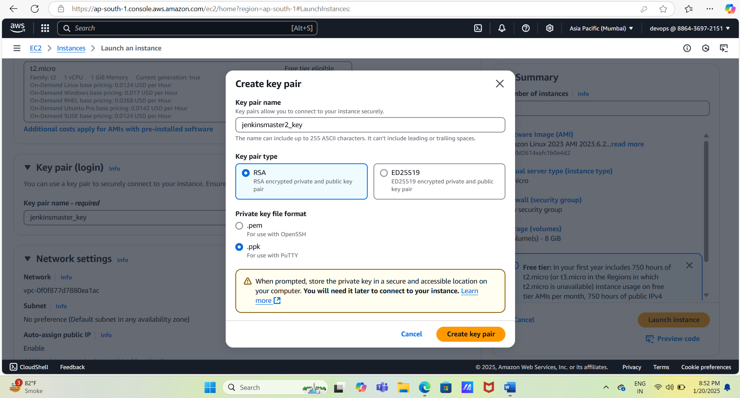

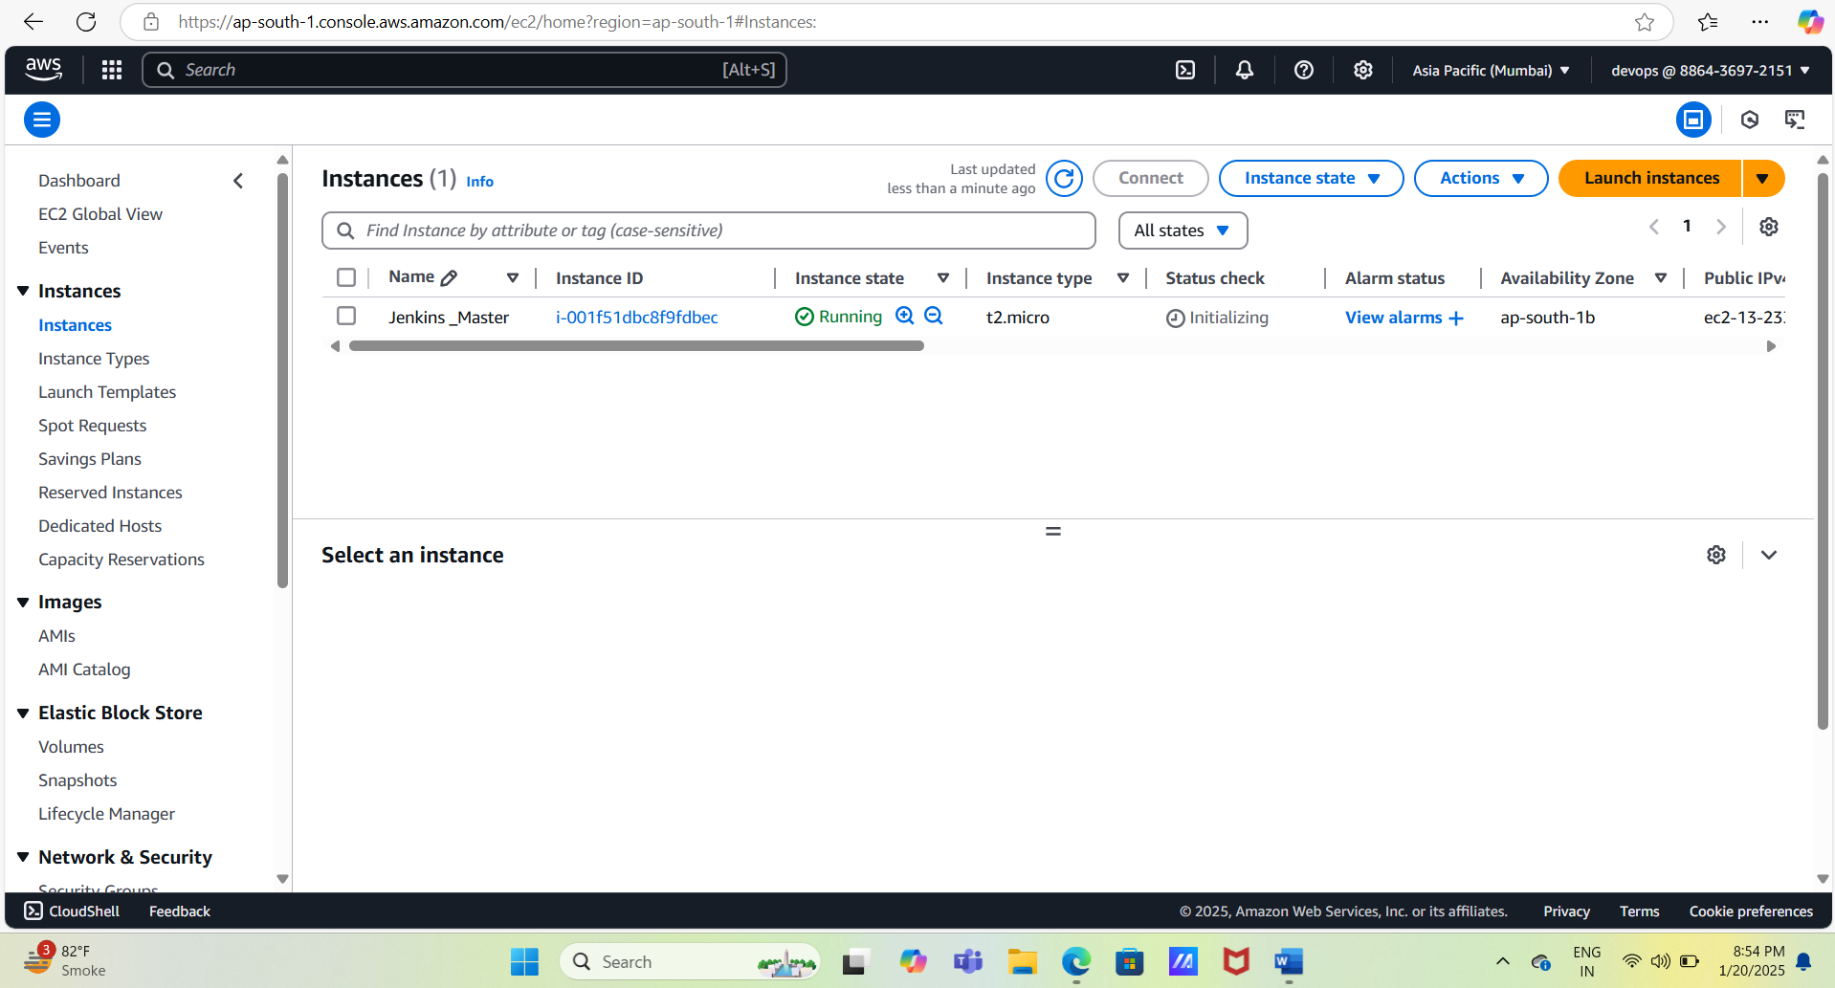

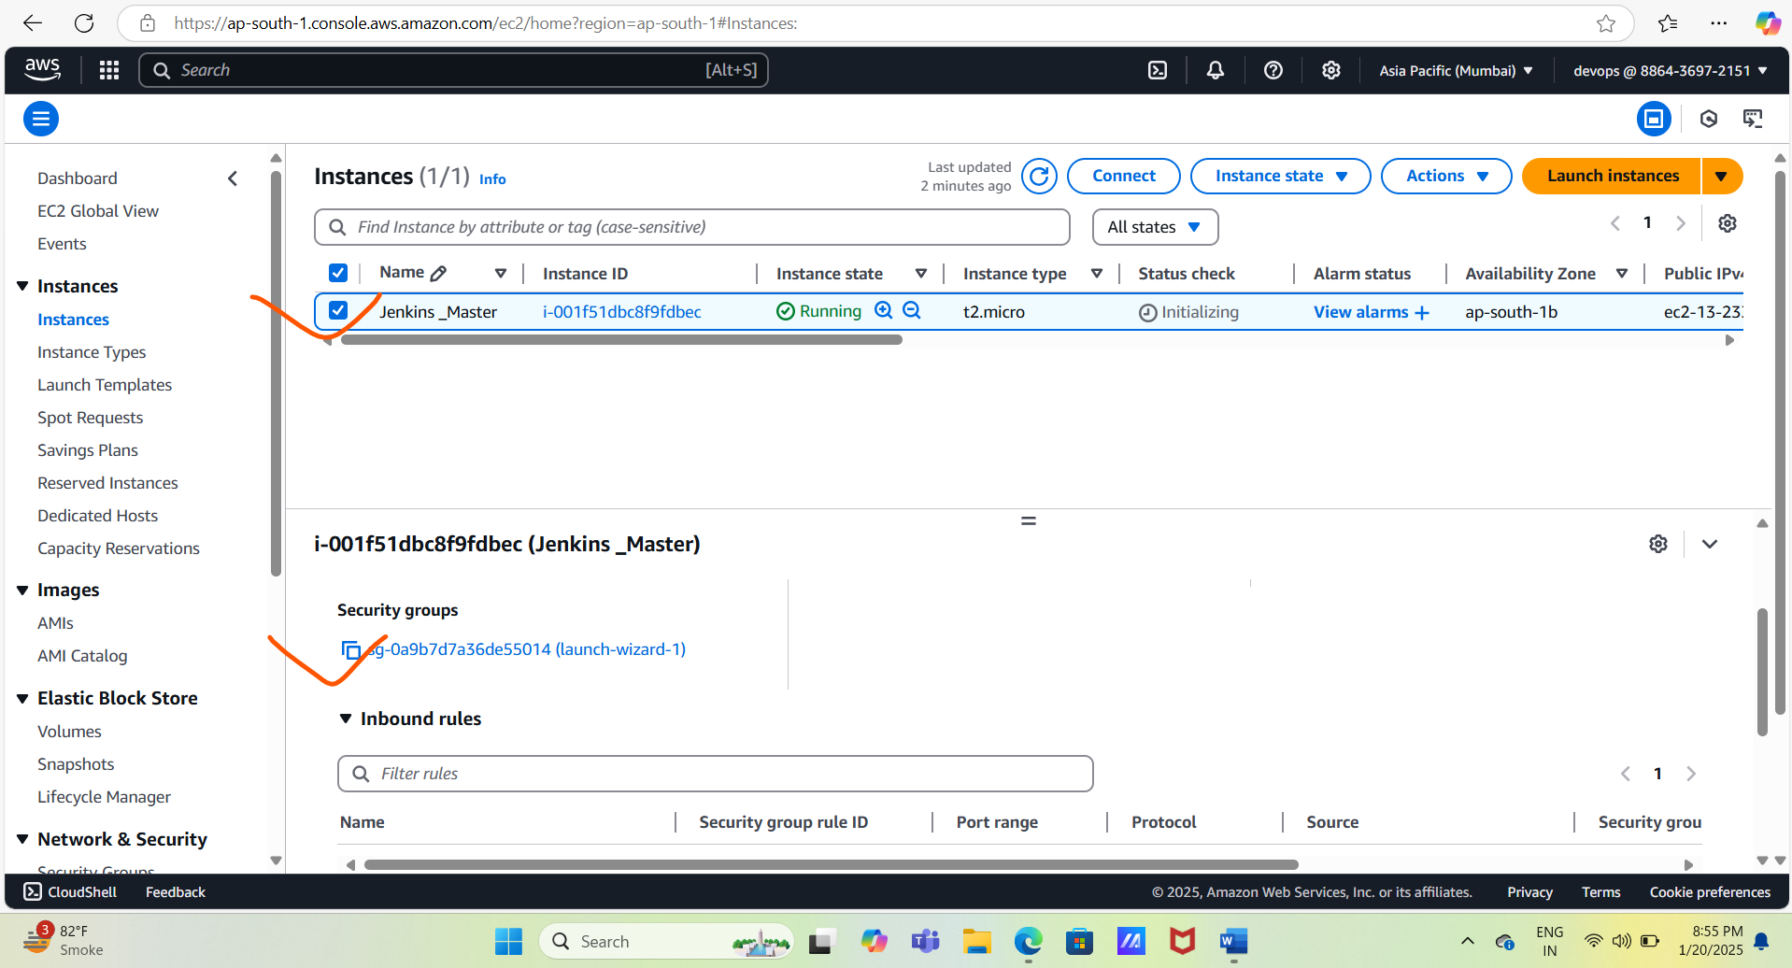

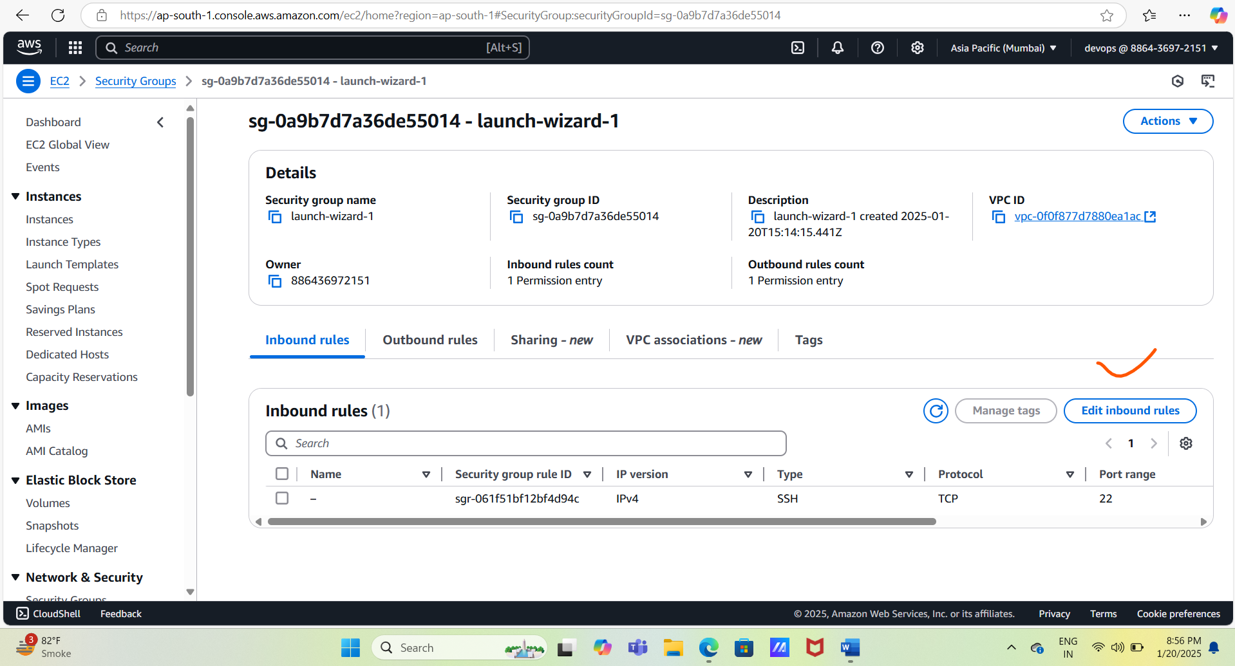

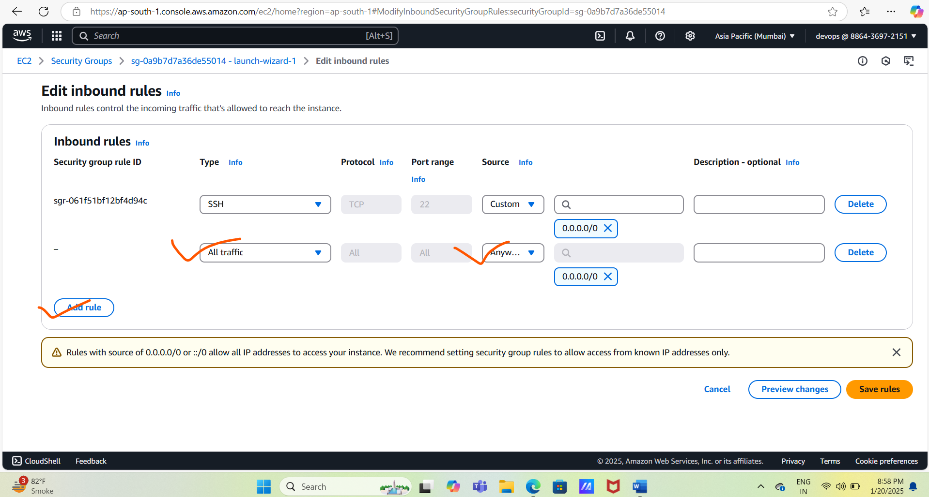

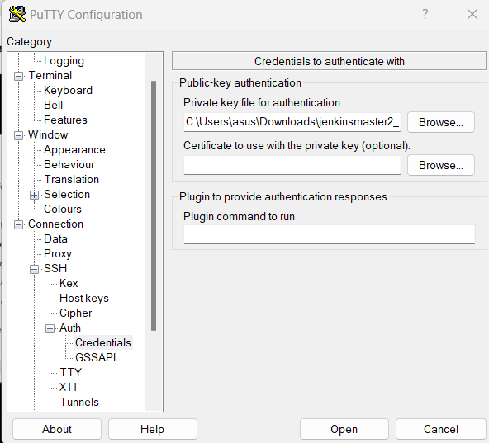

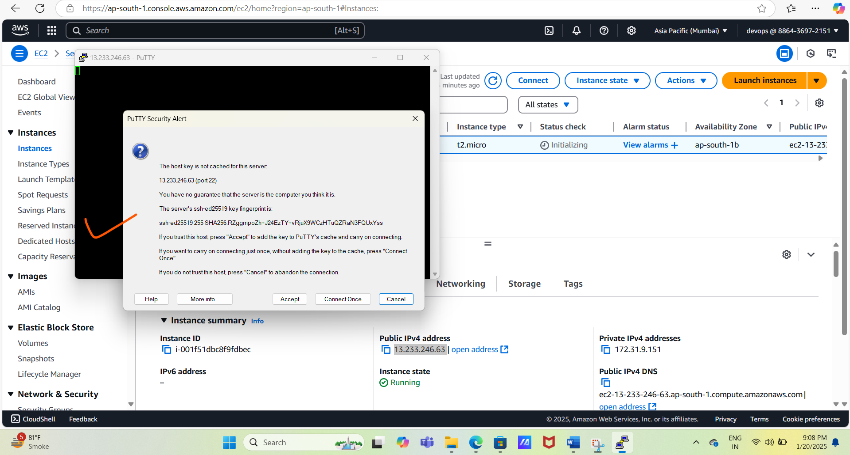

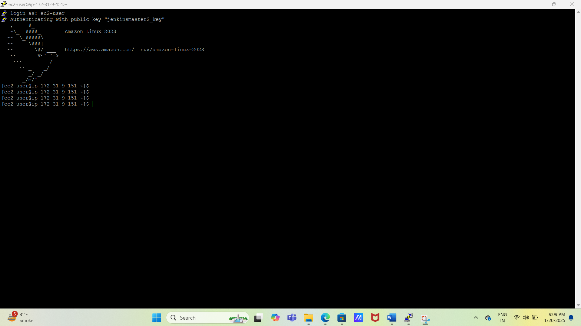

#Installation of Jenkins and other tools which are required to use Jenkins.

#Use command $ sudo su – to login as root.



# Update yum repo list using command $ yum -y update.

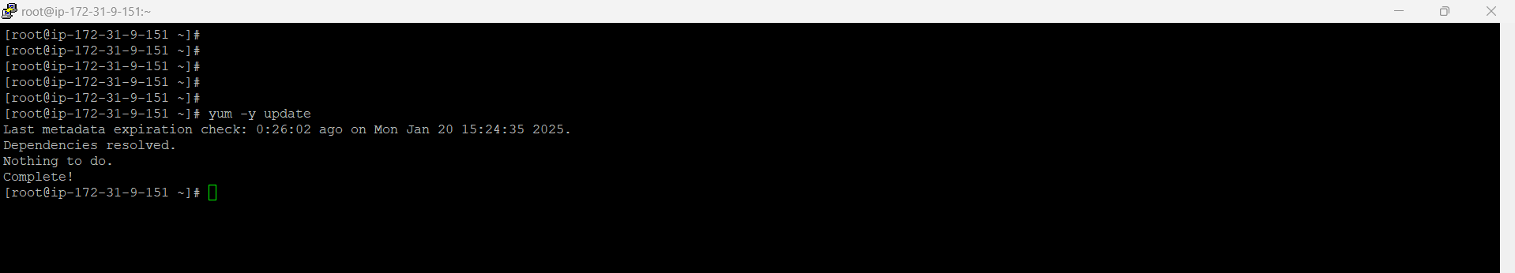

#Install git using command $ yum install -y git

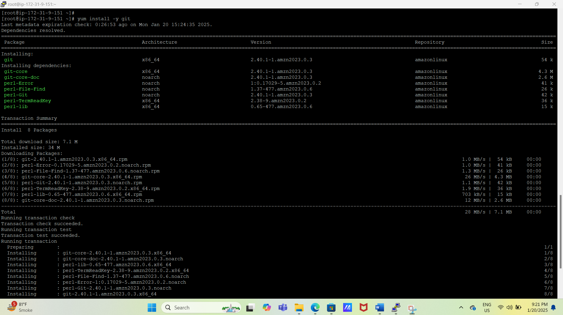

# Check git version using below command $ git –version



# Install java 21 using commands $ yum install -y java-21-amazon-corretto

$ yum install -y java-21-amazon-corretto-devel

$ java –version

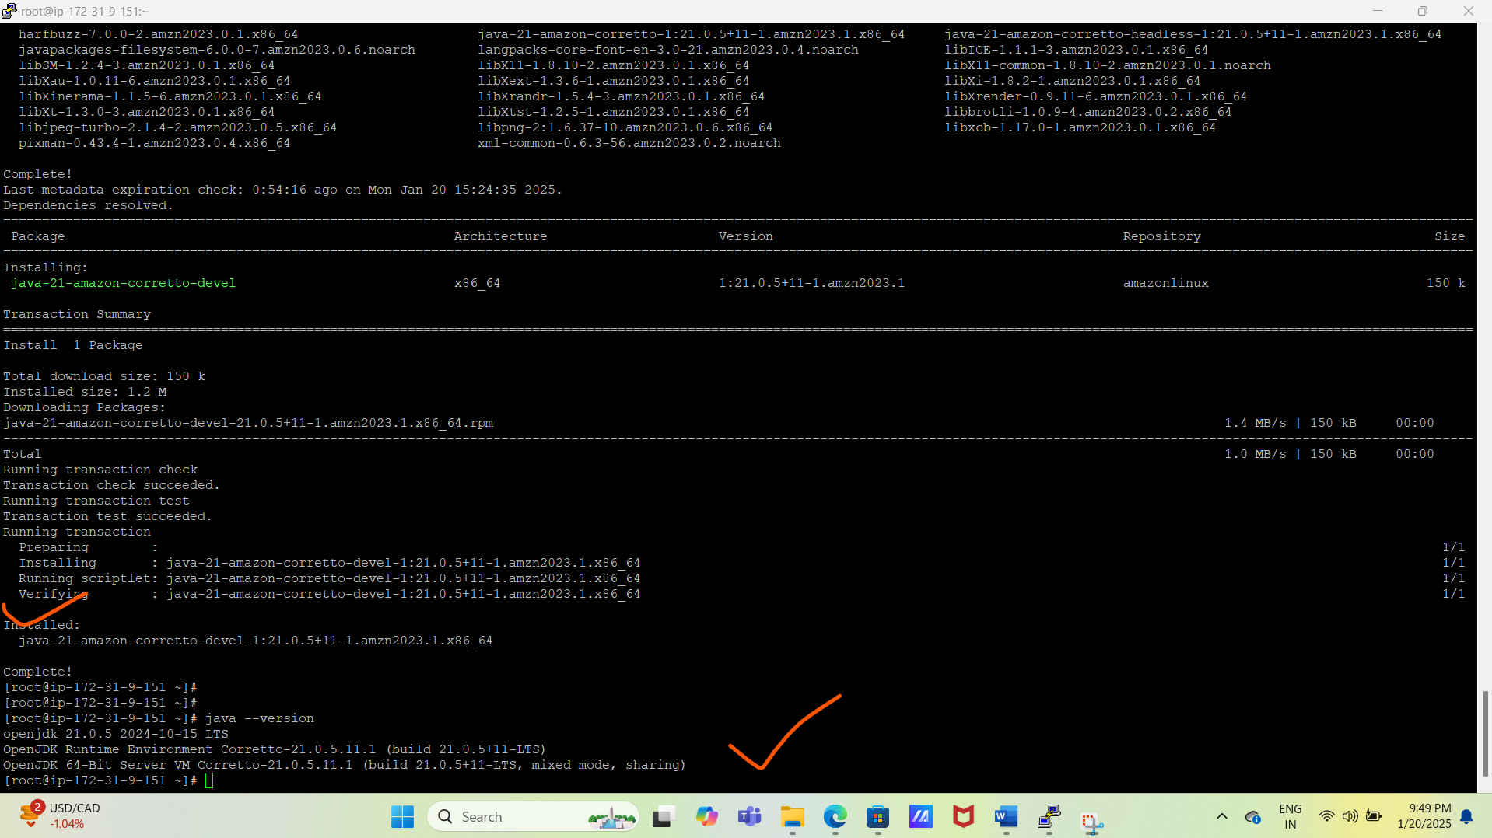

# To check java patch of dir

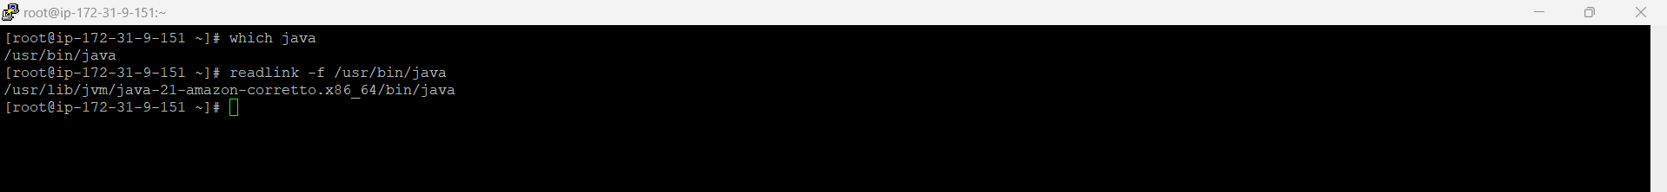

# Install maven using below commands.

$ cd /opt

$ sudo wget <https://dlcdn.apache.org/maven/maven-3/3.9.9/binaries/apache-maven-3.9.9-> bin.tar.gz

$ sudo tar xvf apache-maven-3.9.9-bin.tar.gz

$ ls -ltr

$ cd

$ echo "export M2_HOME=/opt/apache-maven-3.9.9" >> .bash_profile

$ echo "export M2=$M2_HOME/bin" >> .bash_profile

$ echo "export PATH=$M2:$PATH" >> .bash_profile

$ source ~/.bash_profile

$ echo $M2_HOME --to check maven dir path

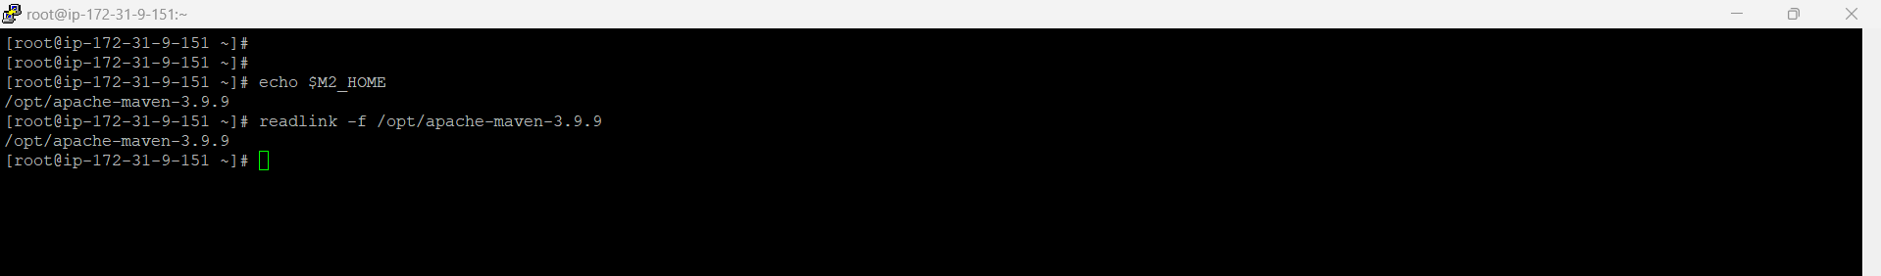

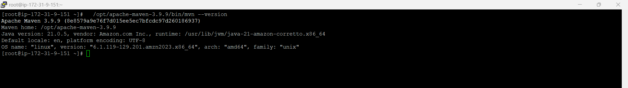

# Install Jenkins using below commands.

$ sudo wget -O /etc/yum.repos.d/jenkins.repo \ https://pkg.jenkins.io/redhat-stable/jenkins.repo

$ sudo rpm --import https://pkg.jenkins.io/redhat-stable/jenkins.io-2023.key

$ sudo yum upgrade

$ sudo yum install -y jenkins

$ sudo systemctl daemon-reload

$ service jenkins start

$ chkconfig jenkins on

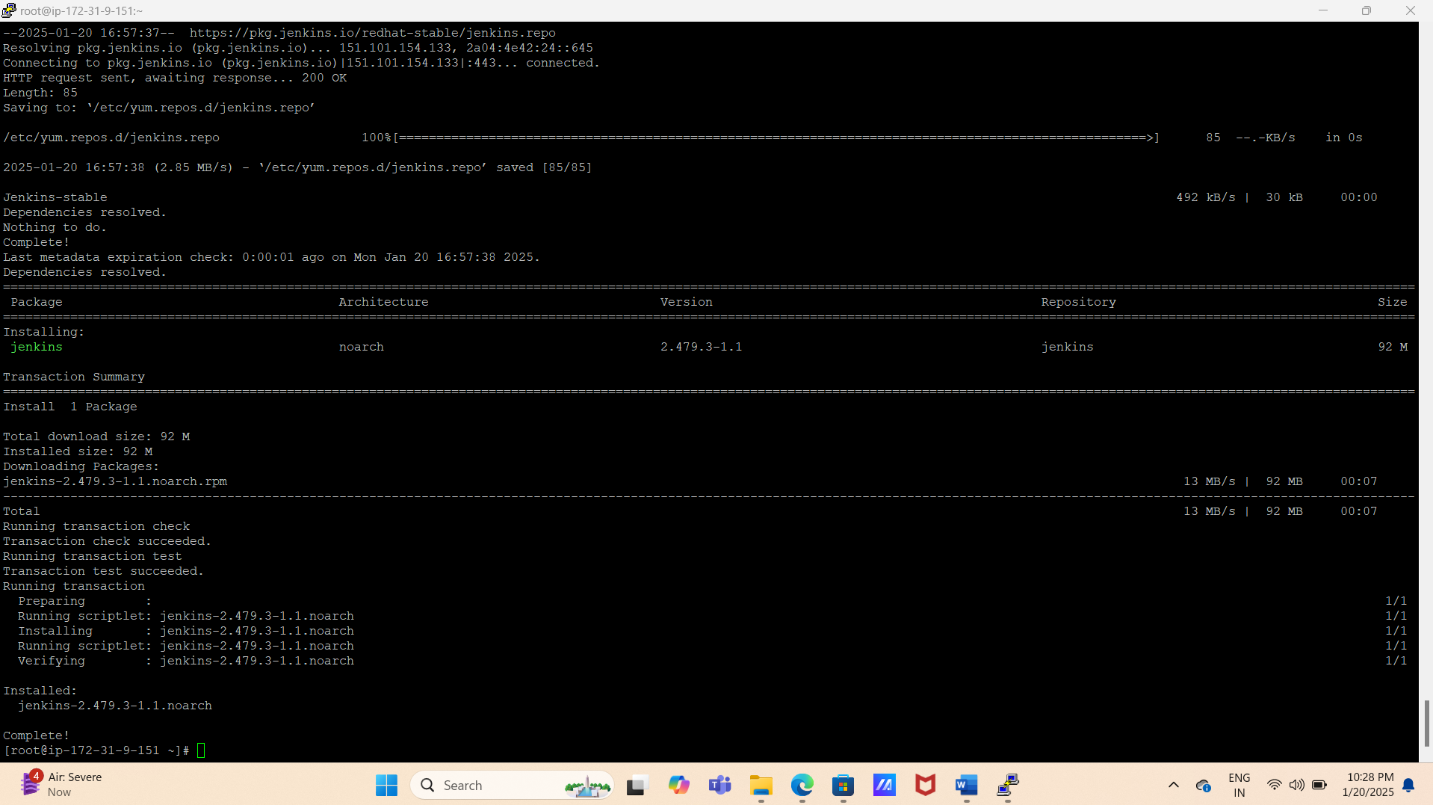

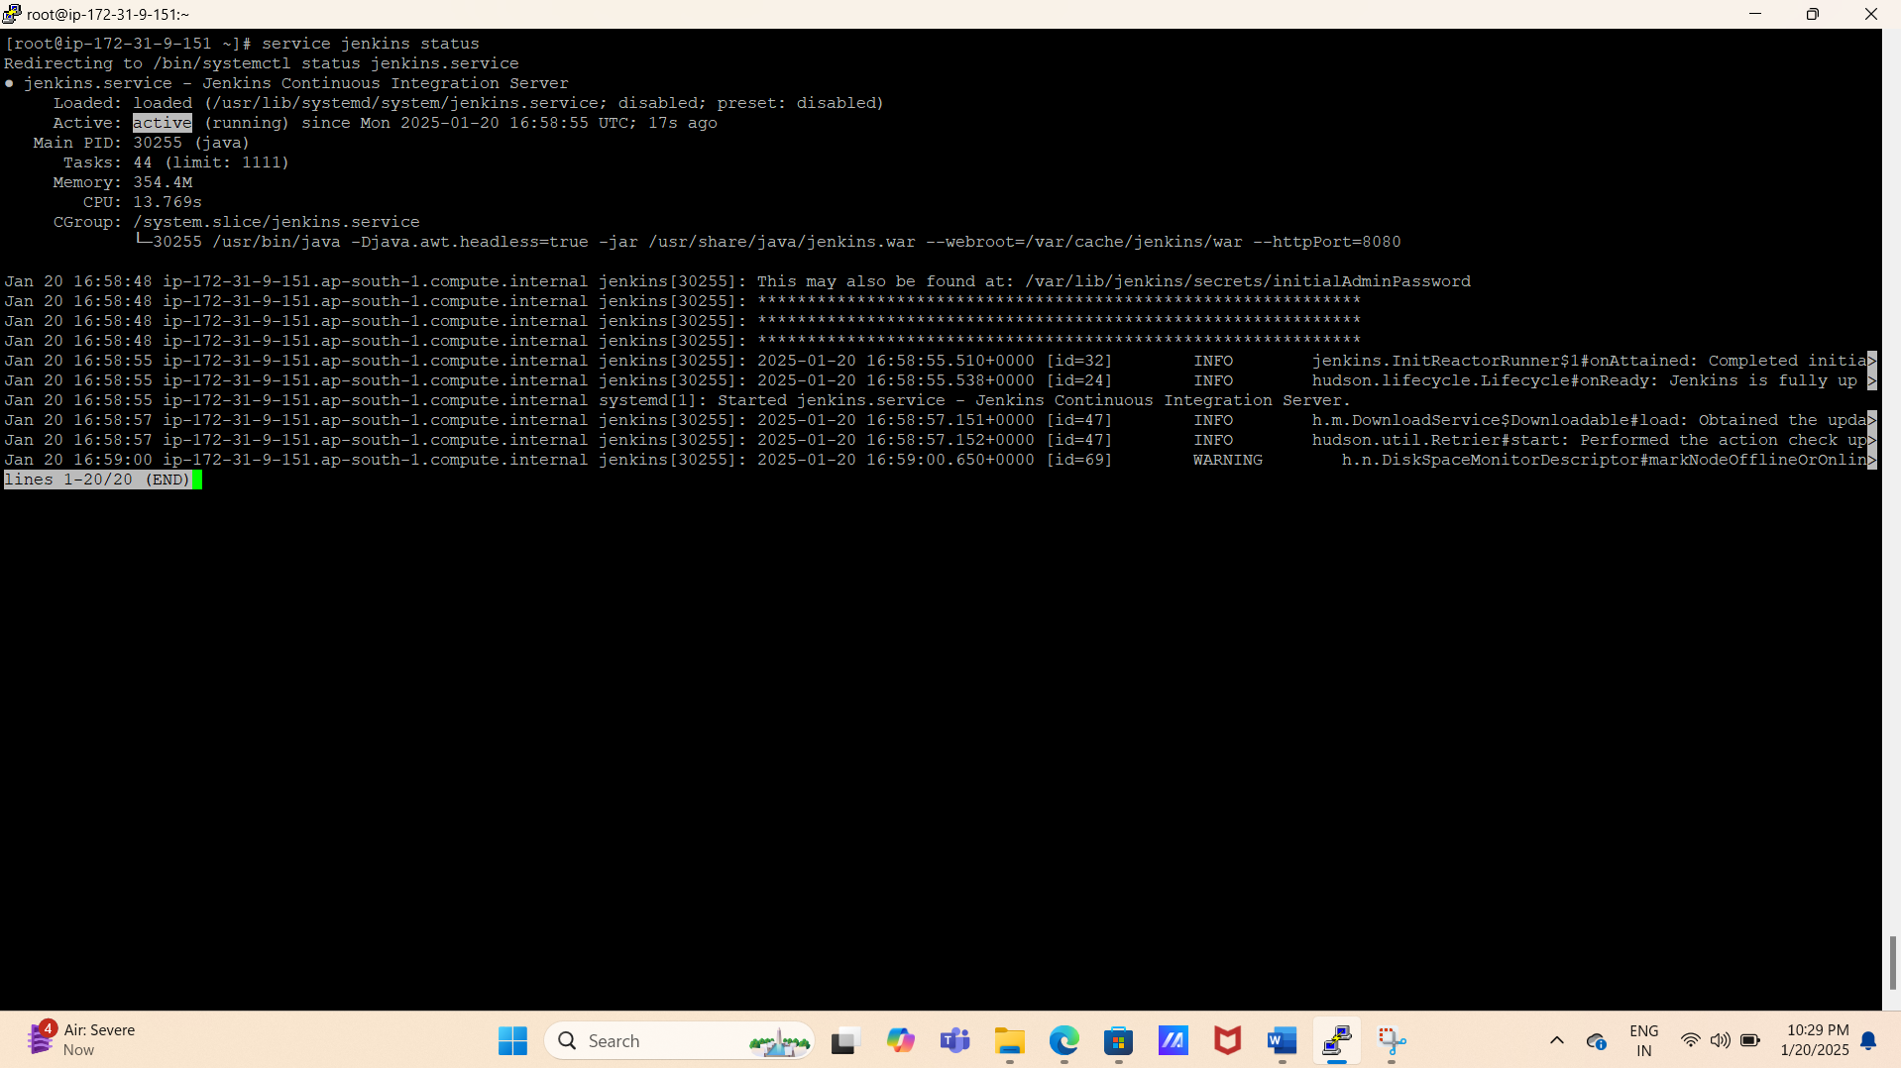

# Login Jenkins using EC2 public IP Address.

Public IP Address: - 13.233.246.63

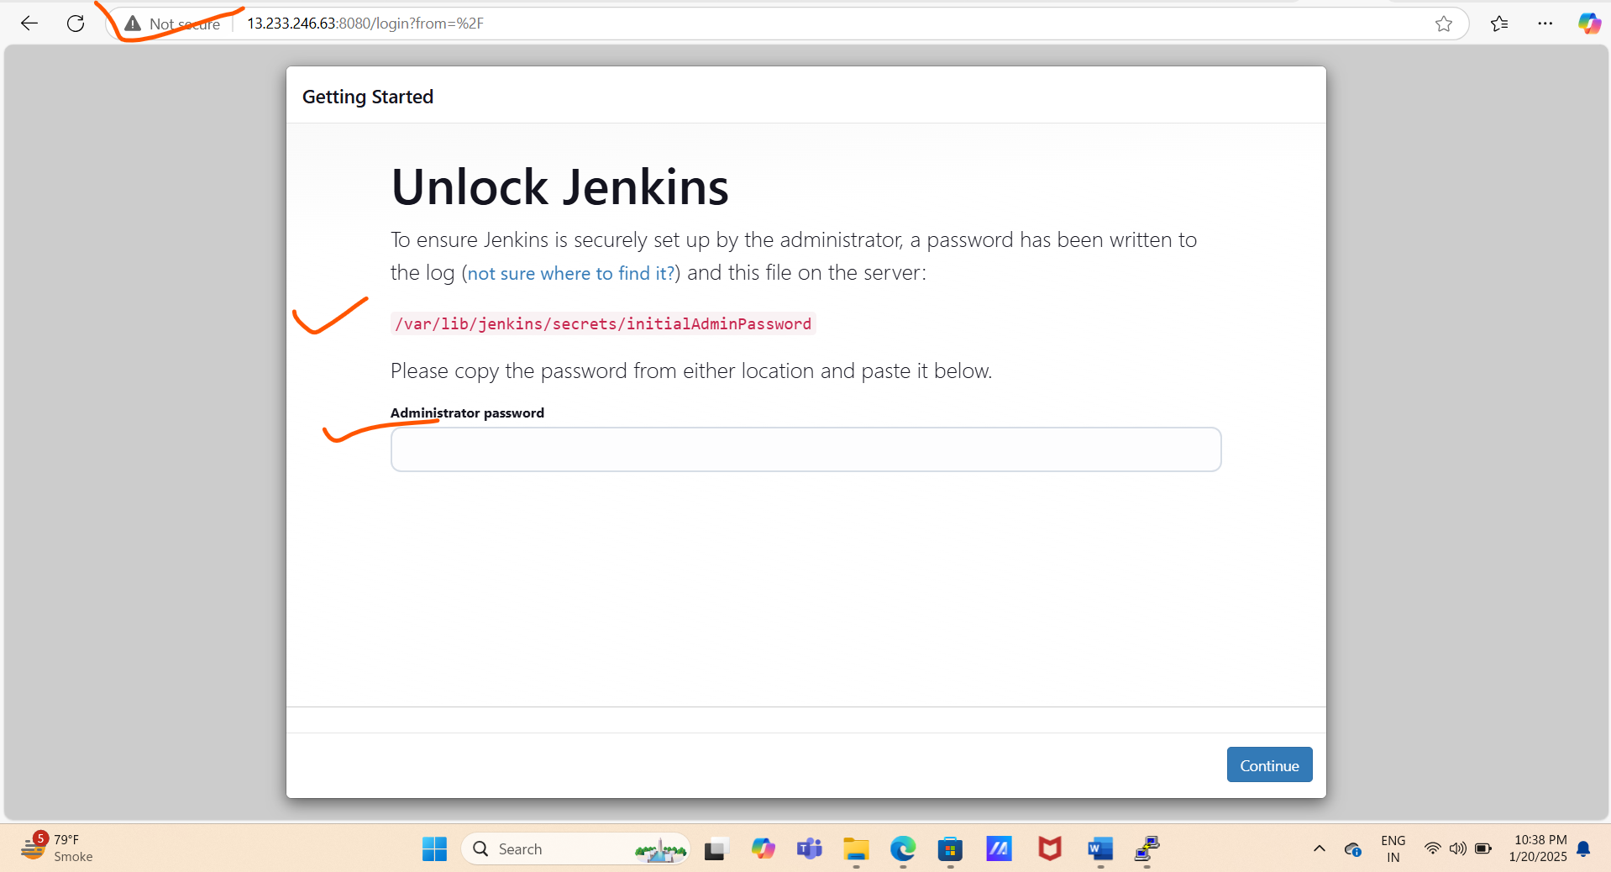

# Copy password using command.

$ /var/lib/jenkins/secrets/initialAdminPassword

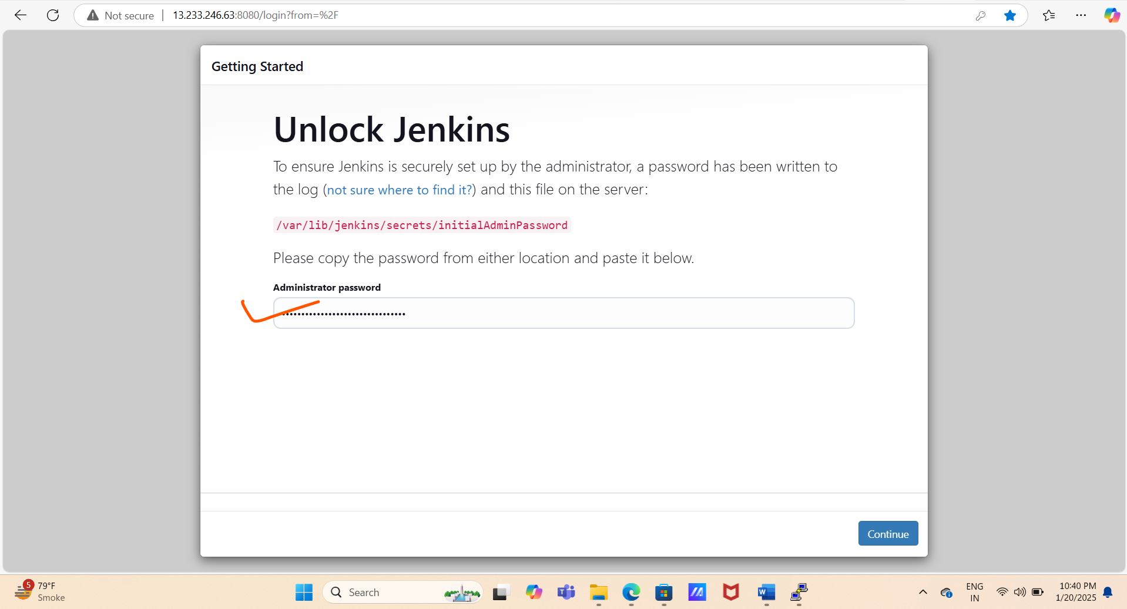

# Click in suggested default plugins and install it.

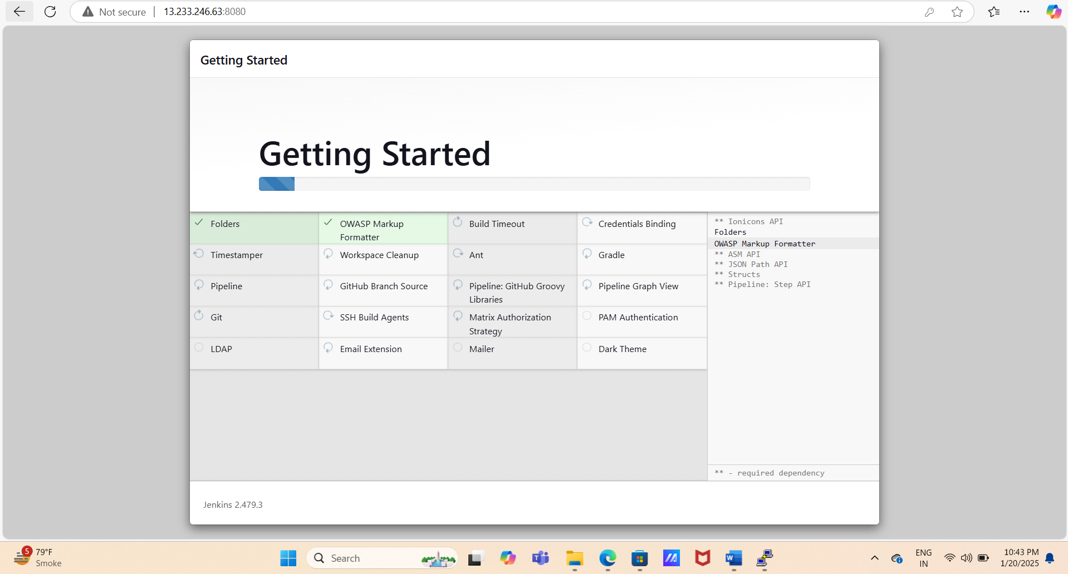

**# Create First Admin User for Jenkins. And Instance Configuration**

**Eg:- user id -ajay and password :- ajay@123**

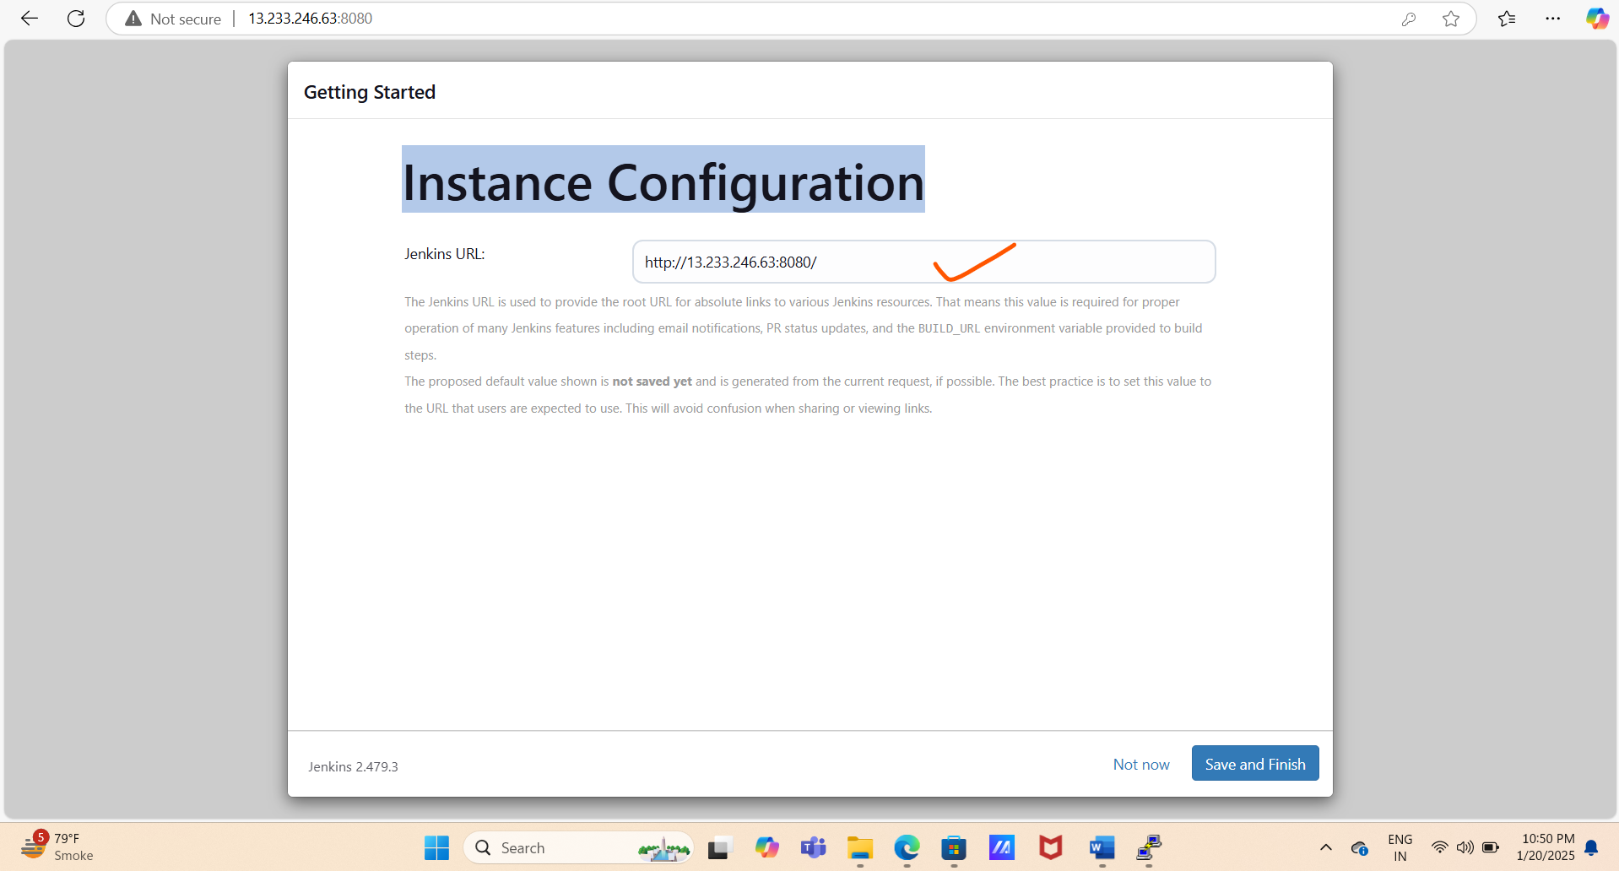

**# Jenkins Installation has been done successfully.**

